Selected Cell: R5C9

Available options include 2 and 3

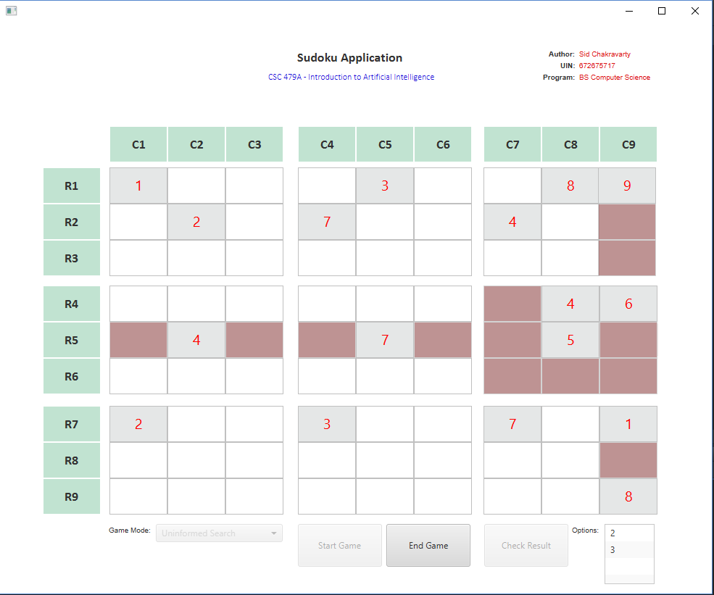

Selected Cell: R5C9

Added new value: 3

Options have been recalculated and now it only shows 2

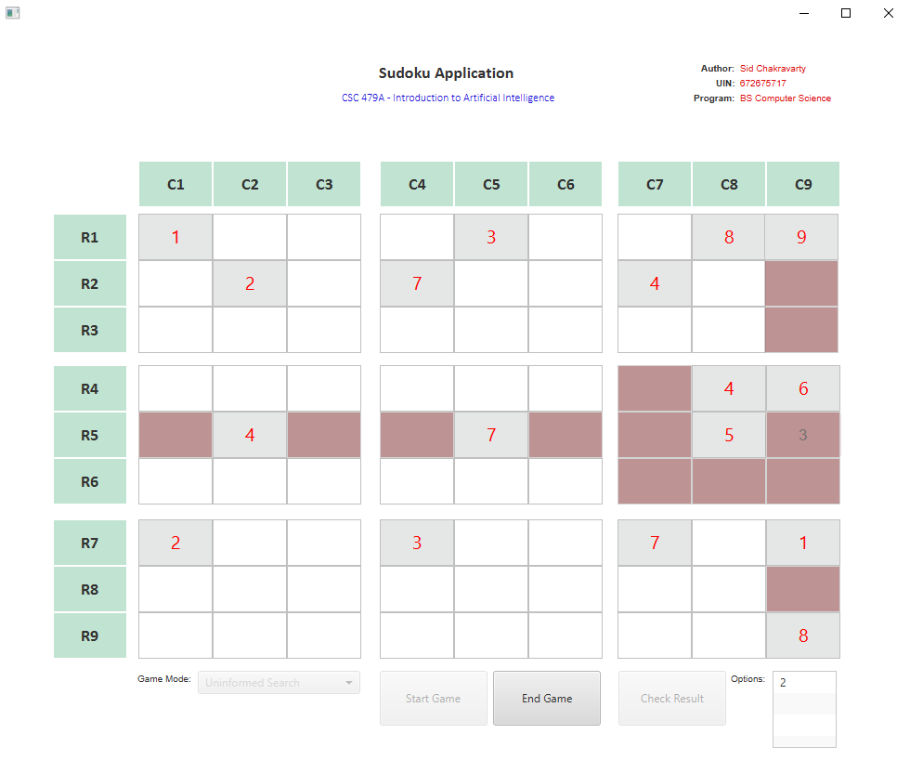

Selected Cell: R3C1

Available options include 3, 4, 5, 6, 7, 8, and 9

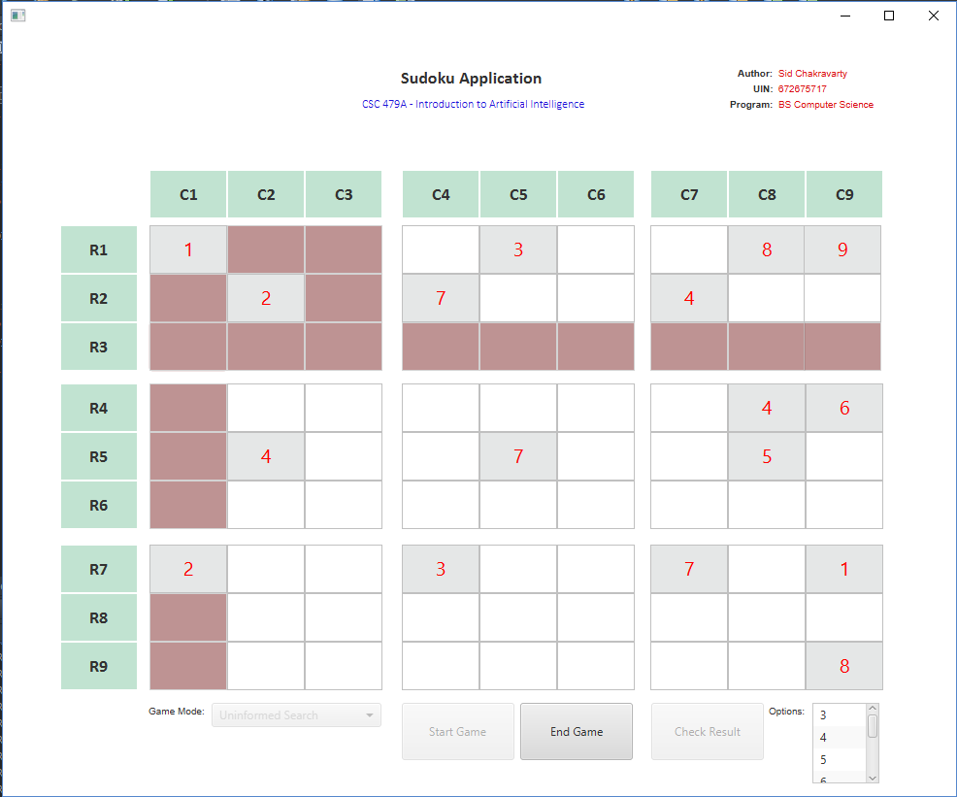

Selected Cell: R3C1

Available options include 2, 3, 6, and 9

